Dashboard and reporting monitoring of NHIT project

- Stakeholder, Areas & Structures
- Stakeholder
  - Project Manager of NHIT : NHIPMPL
  - General Management consultant (GMC Under PM) : Geo Designs & Research Pvt. Ltd.
  - Various Contractor.
  - Special Purpose vehicle (SPV) : NSPPL,NWPPL ,NEPPL
  - Others
- Area of Improvement, monitoring and Management in Road assets
  - Civil
  - Incident Management & Route operation
  - Toll Operations
  - Intelligent Transportation System (ITS) Systems ( TMS ,MLFF,ATMS ,other ITS)
- Organisation structures : (Key & Sub Key professionals )
  - NHIMPL (PM =HQ+site)
  - GMC (HQ+SITE)
  - Various Contractor.
  - Special Purpose vehicle (SPV)
- Document and Approval repository
  - Contract Documents
- Concession Agreement (CA)
- EPC/HAM/BOT Contract Agreement
- O&M Agreement
- Letter of Award (LoA)
- Letter of Acceptance (LoA)
- Work Orders
- Change of Scope Orders
- Supplementary Agreements
- Contract Amendments
- Equipment inventory, warranties, AMC, lifecycle records
- Digital approvals, comments, review history
- Pending approvals, expiring contracts, document status
  - Project Documents
- DPR
- Approved Drawings
- Good for Construction (GFC) Drawings
- As-Built Drawings
- BOQ
- Technical Specifications
- Design Calculations
- Project Schedule
- Baseline Programme
- Monthly Progress Reports (MPR)
- Inspection Reports
- Audit Reports
- Commissioning Certificates
- Completion Certificate
- O&M Manuals
  - ITS/TMS/ATMS Documents
- System Design Documents (SDD)
- FAT Reports
- SAT Reports
- POC Reports
- Network Architecture
- IP Addressing Plan
- Asset Register
- Device Configuration Files
- Software Versions
- Firmware Repository
- OEM Manuals
- Warranty Documents
- AMC Documents
  - Statutory & Compliance Documents
- NHAI Approvals
- IE Certificates
- Safety Audit Reports
- Environmental Clearances
- Insurance Documents
- Licenses
- Statutory Permissions
- Incident Investigation Reports
  - Financial Documents
- Invoices
- Running Account Bills
- Payment Certificates
- Performance Bank Guarantees
- Security Deposits
- Insurance Policies
- Cost Estimates
- Budget Approvals
- Integration and interfacing
  - NHAI Central Command Centre ATMS,TMS
  - Data Lake
  - TMCS & Regional ATMS software of IHMCL
  - Regional HQMS TMS ,MLFF & ATMS
  - Assets Management Systems
  - Rajmarg Yatra
  - Emergency Services 1033
  - ERP
  - E -office
  - Any other software defined by the PM.
- Backup and Disaster Recovery
  - Backup procedure
  - Backup schedule
  - Backup Location (Onsite & offsite)
  - Backup recovery and Restoration
  - DR process
  - Application Availability
- Business Continuity Plan (BCP)
- Etc .
- Attendance and Manpower/ personal availability
  - Employee Name, Employee ID & Photograph, Designation, Discipline and Deployment Location (PIU/Project/Package).
  - Employer Details (Contractor/Consultant/Agency).
  - Attendance Status (Present/Absent/Leave/On Tour).
  - Daily In-Time, Out-Time and Total Working Hours.
  - GPS/Geo-tagged Attendance with Time Stamp.
  - Biometric Attendance Verification (where applicable).
  - Shift Details and Duty Roster.
  - Monthly Attendance Summary and Attendance Percentage.
  - Leave Details (Approved/Pending/Balance).
  - Personnel Availability at Site (Real-time Status).
  - Qualification and Experience Verification.
  - Validity of ID Card, Employment Contract and Police Verification (if applicable).
  - Validity of Mandatory Certifications/Licences (where applicable).
  - Joining Date, Relieving Date and Replacement Details.
  - Vacant Positions and Critical Resource Shortage.
  - Alerts for Absenteeism, Manpower Shortfall and Expired Documents.
  - Daily/Weekly/Monthly Compliance Reports with Download Option.
  - Dashboard Analytics showing:
    - Required vs. Available Manpower
    - Attendance Trends
    - Project-wise and PIU-wise Manpower Status
    - Discipline-wise Deployment Status
    - Compliance Percentage
  - Audit Trail for Attendance Records and Data Modifications.
  - MIS Report Generation (Excel/PDF) with Date-wise, Project-wise and Personnel-wise filters.
  - Real-time Notifications for Non-compliance, Delayed Attendance and Manpower Deficiency.

- Security & access control
  - Access Control
- Role-Based Access Control (RBAC)
- Least Privilege Principle
- Multi-Factor Authentication (MFA)
- Single Sign-On (SSO) with centralized identity management
- Approval workflow for privileged access
- Time-bound access for consultants and contractors
  - Data Classification
- Public
- Internal
- Confidential
- Restricted
- Critical Infrastructure Information
  - Encryption
- AES-256 encryption for data at rest
- TLS 1.3 encryption for data in transit
- Secure encryption key management
- Digital signatures for critical documents
- As per the best industry practice.
  - Audit & Monitoring
- Complete audit trail for all document activities
- User login history
- Download logs
- Upload logs
- Version history
- Document approval workflow
- Automated alerts for suspicious activities
  - Document Security
- Watermarking of downloaded documents
- Read-only viewing for sensitive files
- Version control
- Check-in/Check-out mechanism
- Electronic approvals
- Digital signatures
- Automatic document retention and archival
  - Backup & Disaster Recovery
- Daily incremental backups
- Weekly full backups
- Geo-redundant backup location
- Defined Disaster Recovery (DR) plan
- Periodic restoration testing
- Business Continuity Plan (BCP)
  - Network Security
- Secure Government/NHAI network or VPN access
- Firewalls
- Intrusion Detection/Prevention Systems (IDS/IPS)
- Web Application Firewall (WAF)
- Network segmentation
- Zero Trust Architecture where feasible
  - Endpoint Security
- Anti-malware and Endpoint Detection & Response (EDR)
- Device compliance checks
- USB/media control
- Secure mobile access through MDM (if applicable)
  - Cyber Security Compliance
- MeitY Cyber Security Guidelines
- CERT-In Directions
- National Cyber Security Policy
- ISO/IEC 27001 (Information Security Management)
- ISO 22301 (Business Continuity Management)
- OWASP Top 10 controls for web applications
- NHAI and MoRTH information security requirements
  - Confidentiality Measures
- Non-Disclosure Agreements (NDA) for users with privileged access
- Restricted access to critical infrastructure documents
- No sharing through unauthorized email or external cloud platforms
- Controlled printing with watermarking and logging
- Secure document destruction and retention policy
- Periodic access review and user recertification

- Vendor Management
  - Brief of Each contractor
  - Progress updates
  - Delay with respect Sch F
  - Inspection reports of assets or Defect.
  - EOT & COS details.
  - Payment workflow.
  - Strip charts.
  - Escalation matrix .
- Executive Summary of the NHIT project.
  - General
- Strech details (Basic details)
- Key features on highways.
- Highways Assets details.
- Total Toll Plazas (ETC details lane details, WIM, SWM and other)
- Fee Plaza Tariff: (User Fees details and toll rate period, Revision date etc)
- transaction, FASTag Transaction Percentage Cash Transaction Percentage
- Average Lane Availability
- Peak hour traffic (Lane wise plaza wise, hourly or period wise)
- Actual VS Plan expenditure.
- Physical progress of All work (AVG).

- Civil

  - . Civil Functional Requirements
- Civil Asset Inventory Management, Asset Registration, GIS-Based Civil Asset Mapping
- Pavement Condition Monitoring
- Bridge & Structure Monitoring
- Road Furniture Monitoring
- FDrainage & Culvert Monitoring
- Road Marking & Signage Monitoring
- : Routine Maintenance Management
- Periodic Maintenance Management
- Defect Management
- Complaint Management
- Inspection Management
- Preventive Maintenance Management
- Corrective Maintenance Management
- Asset Lifecycle Management
- Key Performance Indicator (KPI) Dashboard
- Compliance Monitoring
- Notifications & Escalations
- Reporting & MIS
- : GIS Analytics & Mapping

- Toll Management Operations and Systems

  - Traffic Monitoring & revenue Dashboard
- Total Traffic (As per the tariff vehicle class, Various MOP, Journey, etc ) (Daily, weekly, monthly, Yearley ,periodic etc)
- Total traffic (Class wise, Monthly, dally, weekly or period
- Hourly Traffic Trend
- Vehicle Class-wise Traffic (Car, LCV, Bus, Truck, MAV, etc.)
- Direction-wise Traffic
- Peak Hour Analysis
- Queue Length Status
- Average Waiting Time
- Daily Revenue
- Monthly Revenue
- Lane-wise Revenue
- Toll Plaza-wise Revenue
- Vehicle Category-wise Revenue
- Revenue Comparison (Today vs Yesterday / Previous Month)/previous year
  - Toll collection FASTag & ETC Performance
- FASTag Success Rate
- Failed Transactions
- Blacklisted Tags
- Exception Transactions
- Manual Override Cases
- Whitelist/Blacklist Statistics
  - Lane Operations
- Total Lanes
- Active / Closed Lanes
- Lane Health Status
- Lane Downtime
- Equipment Availability
- Operator Performance
  - IT Incident Management
- Lane Breakdown
- TMS critical reequipment (RFID reader, Barrier, TLC, AVC,,LPIC/ANPR ,WIM ,SWB etc (Equipment CCTV Status
- (Equipment Failure
- Communication Failure.
- Surveillance System (Plaza, Lane)
- Telecom breakdown
- UPS/Power Failure
- Incident Resolution Time overall and each equipment.
  - TMS System Health Monitoring
- TMS Server Status (primary and Secondary)
- Network Connectivity local, ISP and CCH
- CCH status
- TMS critical reequipment (RFID reader, Barrier, TLC, AVC,,LPIC/ANPR ,WIM ,SWB etc) Equipment Status
- Power / UPS Battery Status
  - Enforcement & Exceptions
- Overloaded Vehicles (WIM)
- Manual Toll Collection Cases
  - Financial Analytics
- Revenue Target vs Achievement
- Plaza-wise Collection
- Revenue Trend Analysis
- Monthly Growth
- Year-on-Year Comparison
  - Reports & Analytics
- Daily Toll Collection Report
- Traffic Report
- Lane Performance Report
- Incident Report
- Equipment Availability Report
- MIS Dashboard
- Export to Excel/PDF etc .
- AVC Accuracy Reports
  - Other TMS details
KPI | Target | Achieved
FASTag Penetration | >98% | 70%
Lane Availability | >99% | 100 %
Transaction Success Rate | >99.5%
Average Transaction Time | <3 sec
Queue Length | <10 Vehicles
Incident Resolution Time | <30 min
Equipment Availability | >99%
Network Availability | >99.5%
AVC Accuracy Details | >95 %

- Incident Management & Route Operations

  - Executive Dashboard
- Total Highway Length under Monitoring
- Total Packages/Projects
- Total Route Patrol Vehicles (RPV)
- Total Ambulances
- Total Tow-away Cranes
- Total Incident Response Vehicles
- Active Incidents
- Cleared Incidents
- Average Incident Response Time
- Average Incident Clearance Time
- Highway Availability (%)
- Lane Closure Status
- Weather Alerts
- Emergency Alerts
  - GIS-Based Highway Map
- Live GIS Map of NH Corridor
- Chainage-wise Incident Location
- GPS Location of Route Patrol Vehicles
- Ambulance Tracking
- Crane Tracking
- Recovery Vehicle Tracking
- Road Closure/Diversion
- Toll Plaza Status
- CCTV Camera Locations
- VMS Locations
- Emergency Call Box Locations
- Hospitals
- Police Stations
- Fire Stations
- Fuel Stations
- Traffic Density Overlay

  - Incident Management
- Incident Categories
    - Road Accident
    - Vehicle Breakdown
    - Fire Incident
    - Medical Emergency
    - Oil Spill
    - Hazardous Material Spill
    - Animal on Road
    - Debris on Carriageway
    - Flooding
    - Landslide
    - Fog/Low Visibility
    - Potholes
    - Road Damage
    - Vehicle Overturning
    - Wrong Way Driving
    - Security Incident
    - Traffic Congestion
- Incident Details
- Incident ID
- Date & Time
- GPS Location
- Chainage
- Highway Number
- Direction
- Severity (Low/Medium/High/Critical)
- Source (CCTV, Patrol, Helpline, Police, Public)
- Assigned Team
- Current Status
- Estimated Clearance Time
- Actual Clearance Time
- Photographs/Videos
- Incident Report

  - Route Operations Dashboard
- Route Patrol Monitoring
- Patrol Vehicle Status
- Current GPS Location
- Route Coverage
- Patrol Schedule
- Missed Patrols
- Patrol Speed
- Route Compliance
- Patrol Duration
- Fuel Consumption
- Vehicle Health
- Patrol Activities
- Assistance Provided
- Hazard Removal
- Disabled Vehicle Assistance
- Road Safety Inspection
- Emergency Support
- Public Complaints Attended

  - Emergency Response Dashboard
- Ambulance
- Availability
- Response Time
- GPS Tracking
- Cases Handled
- Hospital Reached
- Patient Status
- Tow Crane
- Available/Busy
- Current Location
- Vehicles Recovered
- Recovery Time
- Rescue Team
- Team Availability
- Team Location
- Equipment Status

  - Road Condition Monitoring
- Potholes
- Pavement Damage
- Shoulder Damage
- Guard Rail Damage
- Median Damage
- Signage Damage
- Road Marking Deficiency
- Drainage Issues
- Encroachment
- Water Logging
- Vegetation Obstruction

  - CCTV Monitoring
- Live Camera Feed
- Camera Health
- Offline Cameras
- AI Incident Detection
- Vehicle Detection
- Queue Detection
- Smoke Detection
- Wrong Way Detection
- Pedestrian Detection

  - Weather Monitoring
- Rainfall
- Temperature
- Visibility
- Fog Alert
- Wind Speed
- Water Logging Alert
- Flood Alert
- Lightning Alert

  - Traffic Operations
- Traffic Volume
- Average Speed
- Travel Time
- Congestion Level
- Queue Length
- Lane Closure
- Diversion Status
- Peak Hour Analysis

  - Asset Monitoring
- Patrol Vehicles
- Ambulances
- Recovery Vehicles
- Cranes
- CCTV
- VMS
- Emergency Call Boxes
- Speed Detection Cameras
- Weather Stations
- UPS
- DG Sets
- Communication Network

  - 11. SLA Monitoring
- Incident Detection Time
- Dispatch Time
- Response Time
- Site Arrival Time
- Incident Clearance Time
- Road Restoration Time
- SLA Compliance
- SLA Violations
- Penalties

  - Public Complaints
- Complaint Registration
- Complaint Source
- GPS Location
- Assigned Officer
- Resolution Status
- Resolution Time
- Citizen Feedback

  - Reports & MIS
- Daily Incident Report
- Accident Analysis
- Monthly Route Patrol Report
- Ambulance Performance
- Crane Utilisation
- Road Closure Report
- Hazard Report
- Equipment Availability Report
- SLA Compliance Report
- KPI Dashboard
- Executive Dashboard
- GIS Heat Map
- Incident Trend Analysis

  - Alerts & Notifications
- SMS
- Email
- Mobile App Notifications
- WhatsApp (where approved)
- Command Centre Alerts
- Escalation Matrix
- Emergency Broadcast
- VMS Alerts

  - AI & Analytics
- AI-Based Incident Detection
- Predictive Accident Hotspots
- Black Spot Analysis
- Traffic Prediction
- Route Optimisation
- Asset Health Prediction
- Preventive Maintenance Alerts
  - ATMS Implementation / Execution Progress
- Duct/OFC Installation
- Pole/Foundation Work
- Control Centre
- Equipment Installation
- Power & Network Readiness
  - Device-wise Progress
- TMCS
- VIDES
- VASD
- VMS (Full Type)
- VMS (L Type)
- ECB
- MRCS
- Command Control Centre
  - Device Health
- Online/Offline Status
- Fault Alarms
- Uptime
- Preventive Maintenance
- Corrective Maintenance

  - Recommended Executive KPIs
KPI | Target | Achieved
Incident Detection Time | ≤ 2 minutes
Team Dispatch Time | ≤ 5 minutes
Average Response Time | ≤ 15 minutes
Average Incident Clearance Time | As per incident category/SLA
Route Patrol Coverage | 100%
Patrol Schedule Compliance | ≥ 98%
Asset Availability | ≥ 99%
CCTV Availability | ≥ 99%
Ambulance Availability | 100%
Tow Crane Availability | 100%
Highway Lane Availability | ≥ 99%

- Indicative Dashboard Architecture.



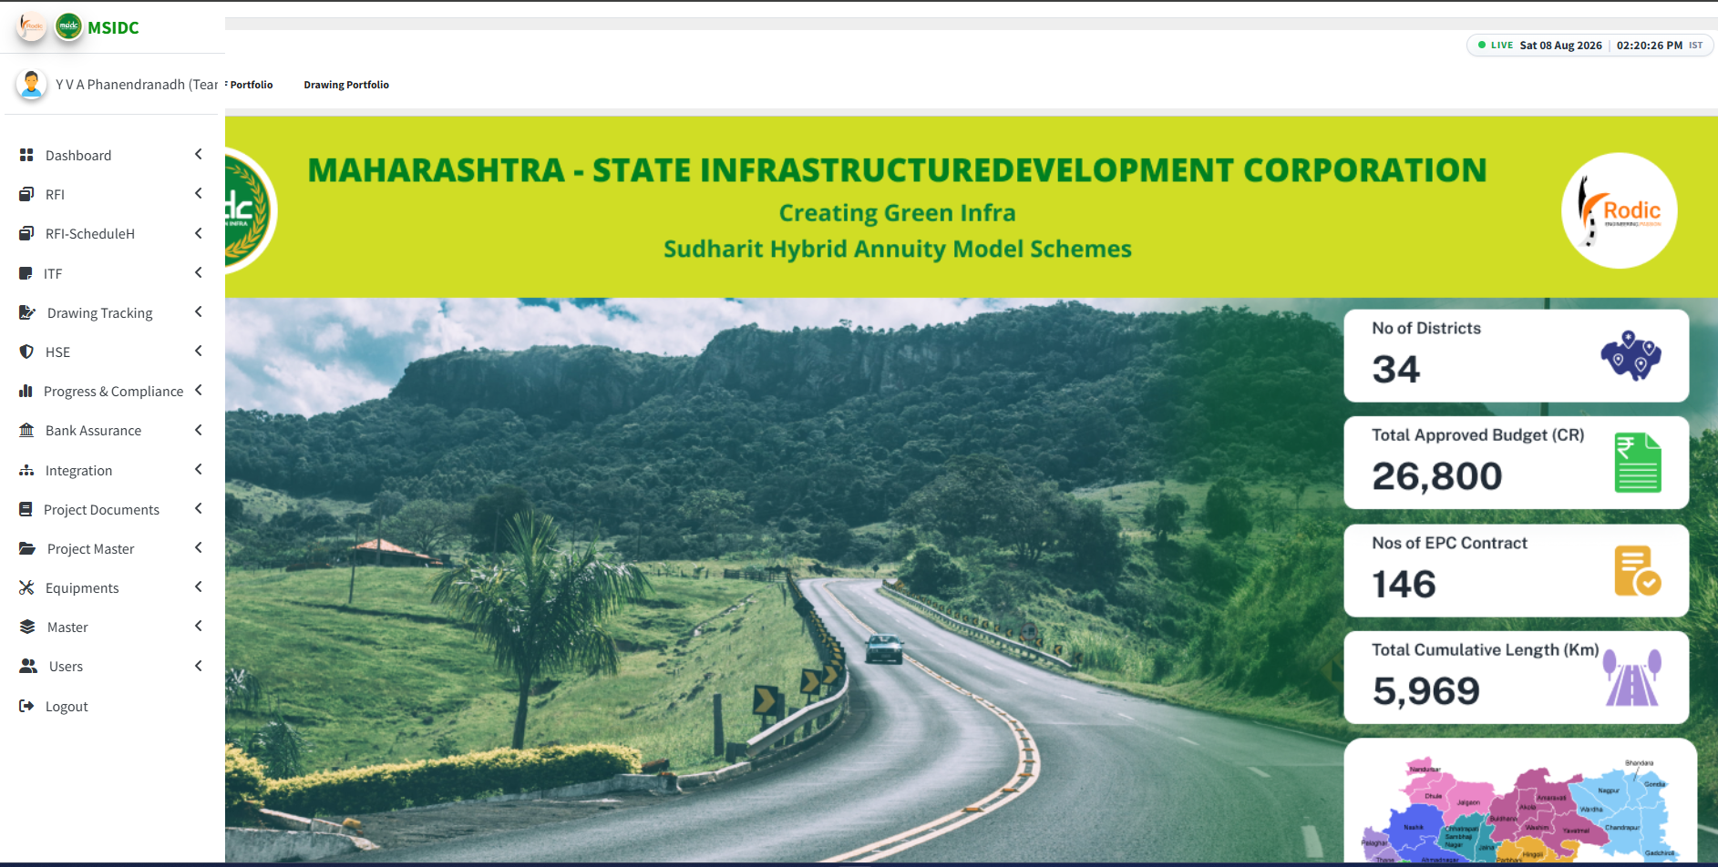

      - Interface View of the Dashboard (After Login First View)

Second Page While Click on the project name then open this type of interface shall view
In this Pre Construction visible in this place Civil Dashboard, Construction in this place ATMS , and O&M in this place TMS Dashboard View open with this all date are visible as shown below pictures and accessible while click on that option.
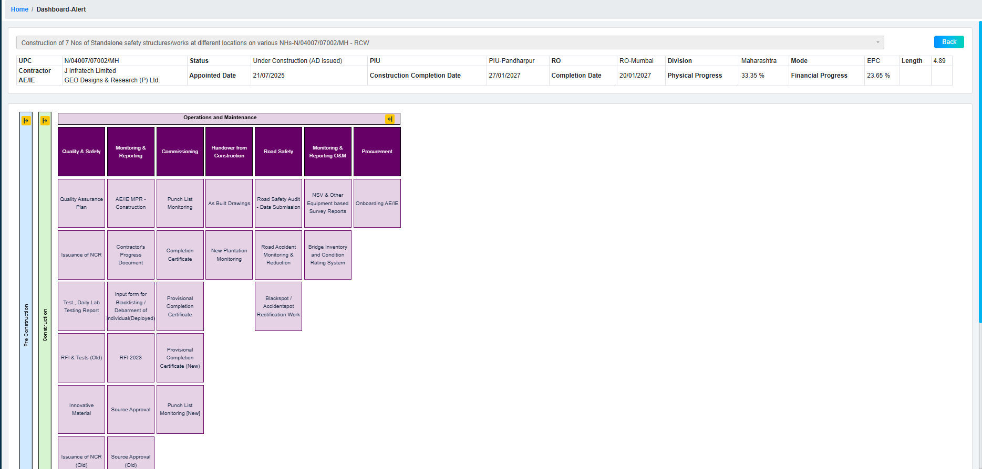
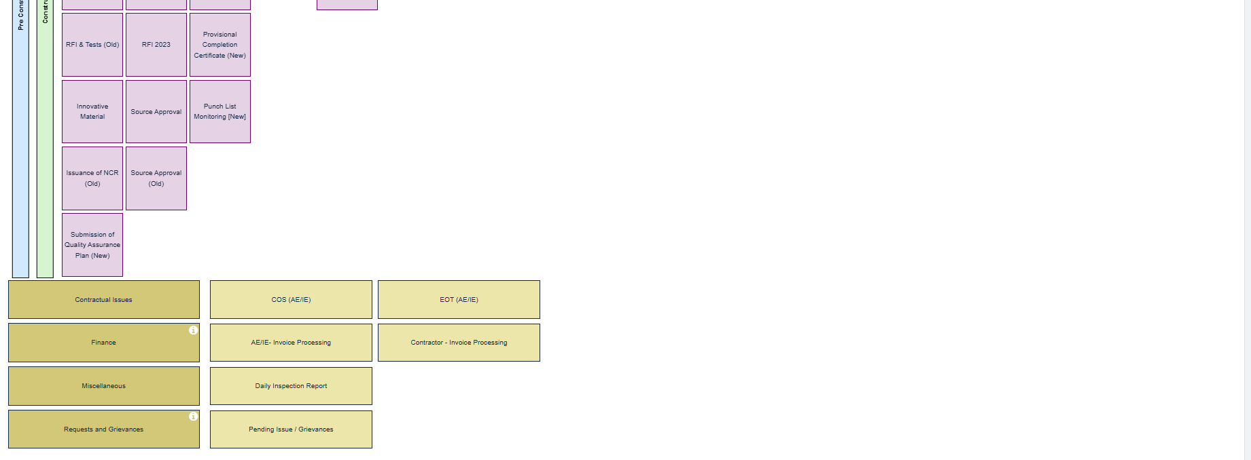

For Today Task (add by the Contractor) Daily Working Activities.

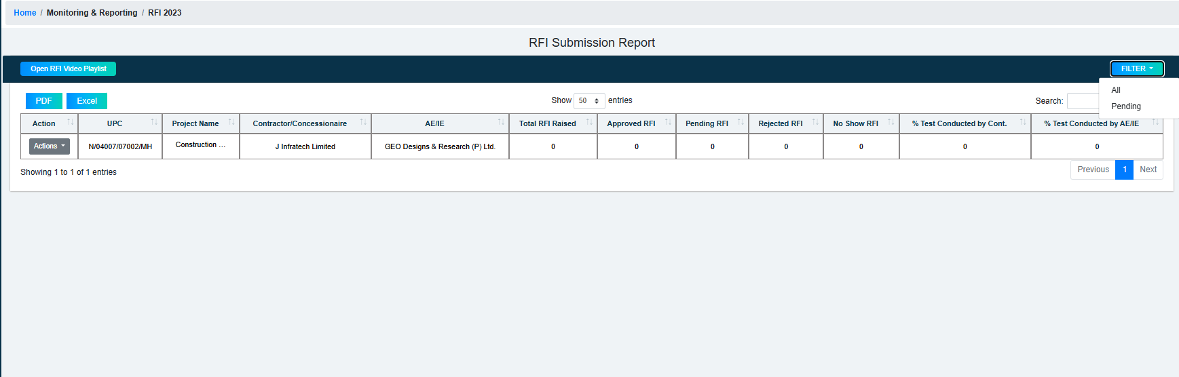

For Documentation upload
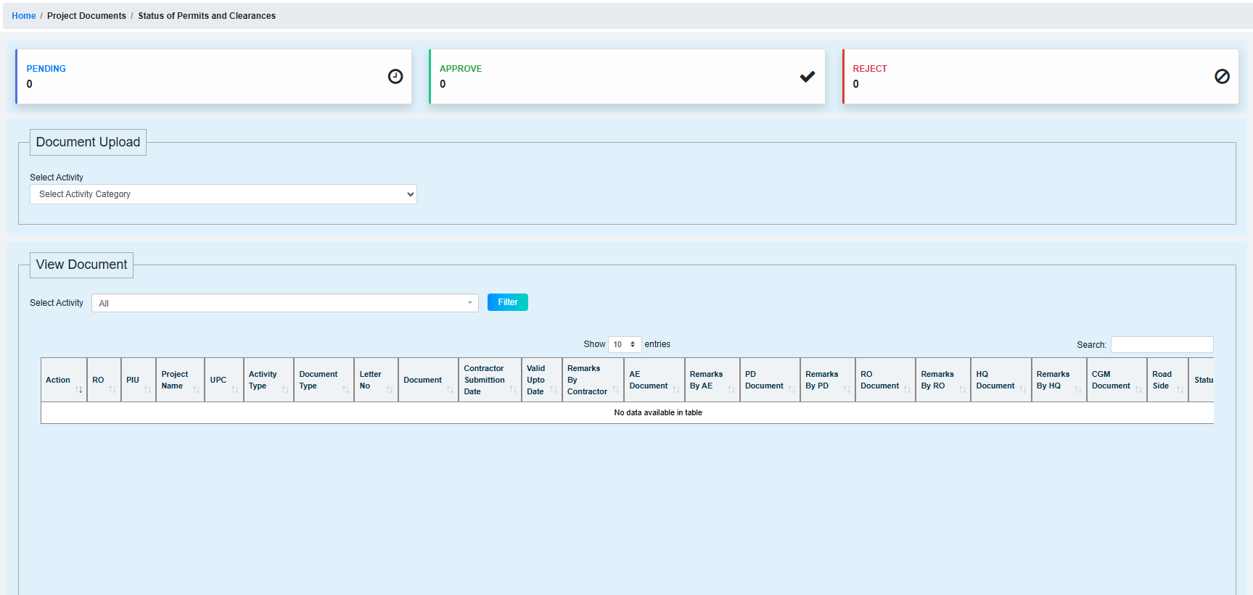

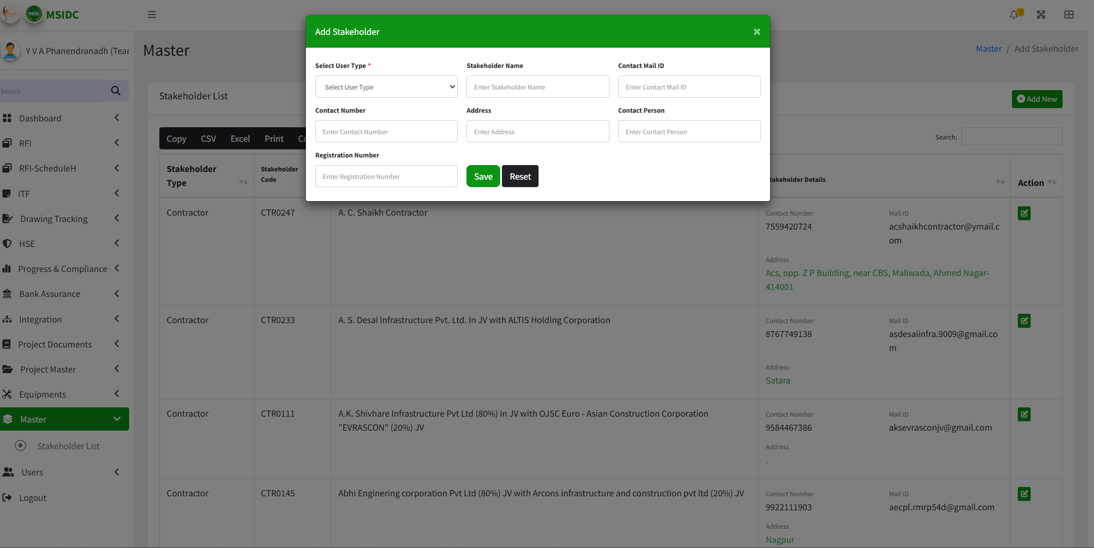
For Vendor Managements

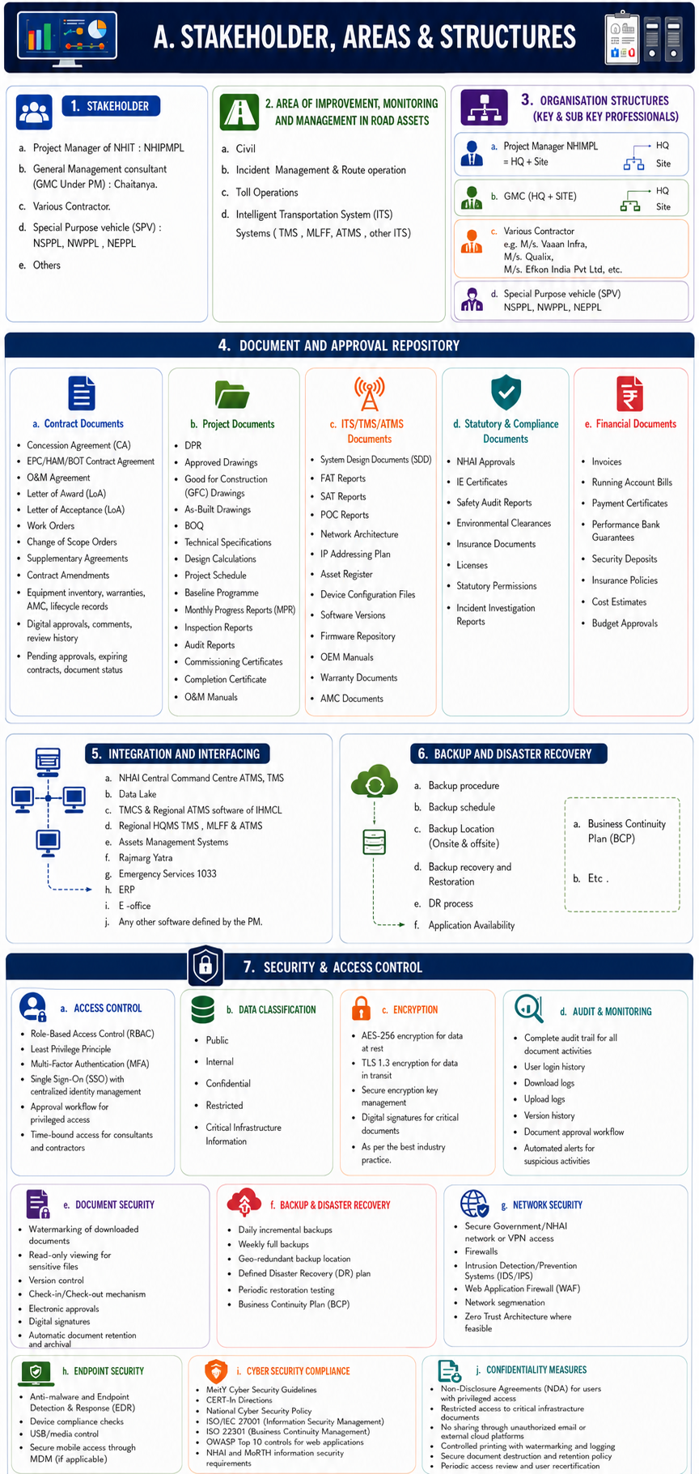
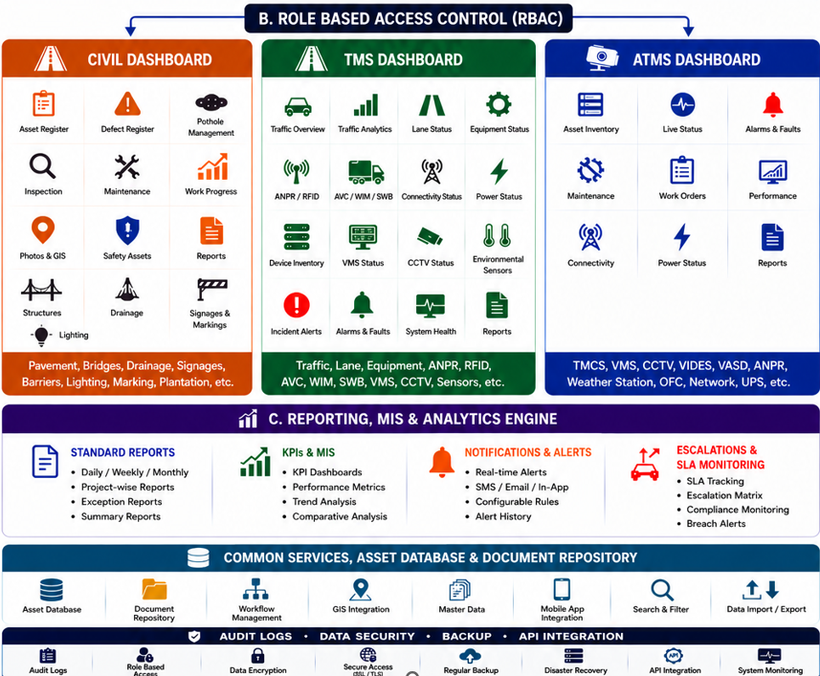

Points to be added for toll operations reports:
Toll Operation Dashboard Requirement
Serial No | Category | Method of Payment | Sub Category
1 | Revenue
 | 1A | Cash Non-Fastag Vehicles
 |  | 1Aa | Single Journey
 |  | 1Ab | Return Journey
 | 1B | UPI Non-Fastag Vehicles
 |  | 1Ba | Single Journey
 |  | 1Bb | Return Journey
 | 1C | ETC
 |  | 1Ca | Single Journey
 |  | 1Cb | Return Journey
 |  | 1Cc | Local Within the District
 |  | 1Cd | Violations
 |  | 1Ce | Chargeback
 | 1D | POS
 |  | 1Da | Local Monthly Pass
 |  | 1Db | Monthly Trip Pass
 |  | 1Dc | Customize Local Monthly Pass
 |  | 1Dd | Customize Monthly Trip Pass
2 | Traffic
 | 2A | Cash Traffic
 |  | 2Aa | Single Journey
 |  | 2Ab | Return Journey
 | 2B | UPI Traffic
 |  | 2Ba | Single Journey
 |  | 2Bb | Return Journey
 | 2C | Exemption
 |  | 2Ca | Authorised Exemption
 |  | 2Cb | Unauthorised Exemption
 | 2D | Violation/Run-through
 |  | 2Da | Genuine Violations
 |  | 2Db | System Generated Violations
 | 2E | ETC
 |  | 2Ea | Single Journey
 |  | 2Eb | Return Journey
 |  | 2Ec | Local Within the District
 |  | 2Ed | Global Exemption
 |  | 2Ee | Local Monthly Pass Trip
 |  | 2Ef | Monthly Pass Trip
 |  | 2Eg | Customize Local Monthly Pass Trip
 |  | 2Eh | Customize Monthly Pass Trip
 |  | 2Ei | Rejection and Reasons
 | 2F | Annual Pass
 |  | 2Fa | No of Total Traffic
 |  | 2Fb | No of Single Trip Traffic
 |  | 2Fc | No of Return Trip Traffic
 |  | 2Fd | No of Qualified Traffic As per IHMCL Guideline
 |  | 2Fe | No of Single Trip Traffic Qualified Traffic As per IHMCL Guideline
 |  | 2Ff | No of Return Trip Traffic Qualified Traffic As per IHMCL Guideline
 |  | 2Fg | Annual Pass Compensation Amount
 |  | 2Fh | Adjustment Exemption Amount
 |  | 2Fi | Final Annual Pass Compensation Amount

Note :-
- Data Visualization Should Be Zone Wise
- Data Visualization Should Be State Wise
- Data Visualization Should Be Assets Wise
- Data Visualization Should Be Project Wise
- Data Visualization Should Be Plaza Wise
- Data Visualization Should Be Lane Wise
- Data Visualization Should Be MOP Wise
- Data Visualization Should Be Class Wise

